Exercise 3
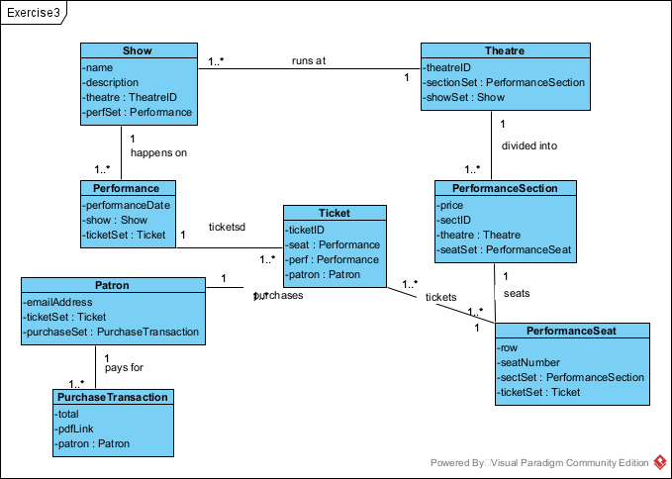
public class Show {
String name;
String description;
Theatre theatreID;
Performance perfSet[];
}
public class Theatre {
int theatreID;
PerformanceSection sections[]t ;
Show showSet[];
}
public class PerformanceSection {
int price;
String sectID;
Theatre theatre ;
PerformanceSeat seatSet[];
}
public class PerformanceSeat {
int row;
int seatNumber;
PerformanceSection sectSet ;
Ticket tickSet[];
}
public class Ticket {
string ticketID;
Performance seat ;
PerformanceSeat perf;
Patron patron;
}
public class Performance {
string PerformanceDate;
Show show;
Ticket ricketSet[];
}

public class Patron {
string emailAddress;
Ticket ticketSet[];
PurchaseTransaction purchaseSet[];
}
public class PurchaseTransaction {
int total;
string pdfLink;
Patron patron;
}

